Board Members Present:
Nancy Savage Marcus
Jaime Beane
Becky McKinnell
Elizabeth Woodcock
Jack Hackendorn
Kim Caldwell
Walt Craven

Neighbors Attending:
Maureen Connelly
Vilean Taggersell
Karen St. Clair
Mary Ann Bradford
Hubba Bradford
Peggy Golden
Donna Levi
Sukie Curtis
Dick Michael
Judy Lambert
Doug Geheb

Agenda:
- Welcome new members, roles, and goals
- Invasives Management Q&A with arborist Mike Hughes
- Treasurer's Report
- Review proposal for treatment of invasive plants in Wildwood Woods
- Bank update and priorities - takeaways from 8/18 meeting with landscape architect Sarah Witte
- Review proposals for stone pillar/wall crack repair at entrance
- Consider donation of blueprint of original Wildwood platt
- Other business

Call to order at 6:05pm

Invasives Management Q&A with Mike Hughes
Welcome Mike Hughes, from Hughes Arbor and Land Management in Freeport! Mike joined our board meeting to answer our questions about invasive management so we can accomplish our goal to maintain the view and have a healthy bank.
With invasive management, the goal is to get the mass of the plant out at the beginning. The main stem is treated first and then it is mechanically removed. The Japanese knotweed and oriental/asiatic bittersweet are the two most important invasives to manage. Others include glossy buckthorn (mimics the chokecherry). These invasives will eradicate all native plants on a site.
September, October, and November are the best times to treat invasives. Springtime treatment is for holding off growth.
Triclopyr is used to treat larger stems. For Japanese knotweed, a hypodermic needle is used to apply the treatment.
Triclopyr is rated as non-toxic. It is not harmful to bees. Mike uses a dye marker so you can see where it is applied.
Regarding our bank, Mike recommends getting rid of the bittersweet since that will take over everything. Bittersweet does not add soil stabilization. We would need to collaborate with Bill Longley for the best way to approach the knotweed and buckthorn. Sarah recommends cutting it to 36” and maintaining it every year, but Mike warns that this method will multiply the bittersweet. Japanese knotweed can be cut back every year without multiplying. Buckthorn is another invasive species that multiplies and must be maintained. Buckthorn can be a soil stabilizer.
We have 4 ash trees that could be infected with Emerald Ash Borer. Once the tree is infested, the ash tree will die in 3-4 years. It is something that we should keep an eye on.
Asiatic Bittersweet:
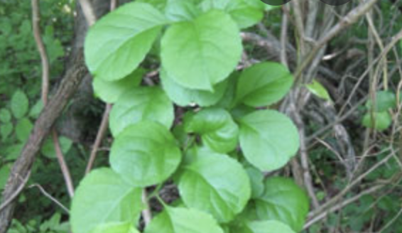
Glossy Buckthorn:
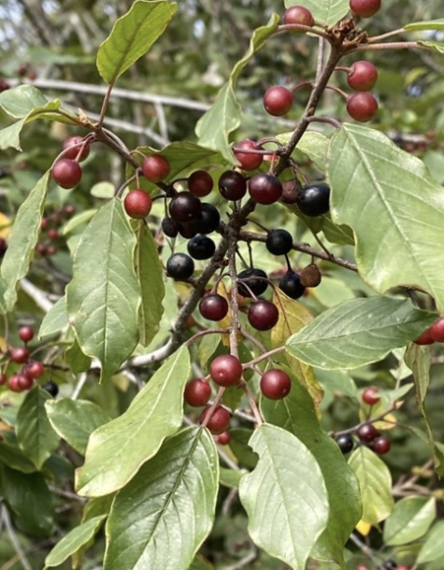
Japanese Knotweed:
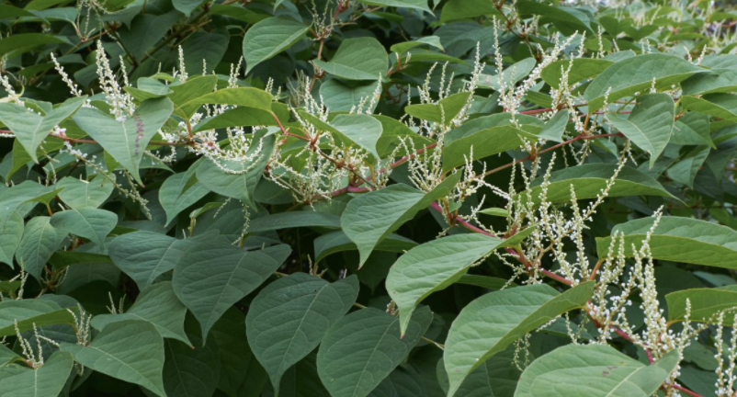
Emerald Ash Borer:
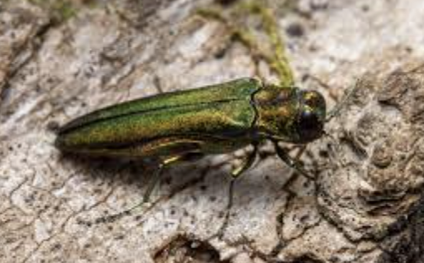

Treasurer’s Report
Budget updates:
- We have about $13,000 still outstanding from this year’s dues.
- We have about $52,000 in cash reserves.
- All of our expenses are on track.
- This year we have $10,000 budgeted to deal with invasives which includes maintaining and improving the view.

As a reminder, next year’s dues will be $500. We’ll need to vote on dues moving forward at our next annual meeting.

Review proposal for treatment of invasive plants in Wildwood Woods
This lot is owned by the Wildwood Association and runs along 88 next to Donna Levi’s house and the Herds. Mike Hughes’ cost to treat and maintain our invasives is $580 per year.

Kim Caldwell is going to call friends of Casco Bay to ask about Triclopyr and how it relates to run-off concerns in the ocean.

Nancy will check with the Judge’s to see what their plan is for invasives. Their plan will inform our decision to move forward with invasive management in the Wildwood Woods.

Bank update and priorities - takeaways from 8/18 meeting with landscape architect Sarah Witte
Elizabeth Woodcock, Jaime Beane, and Kim Caldwell walked the top of the bank and the beach with Sarah to help us identify priorities for a short and long-term bank maintenance plan. The biggest threats to the health of the bank are erosion and invasives. Her 2013 letter still rings true: “it seems sensible - whether our goals are healthy birds and wildlife, views of Casco Bay, or prevention of erosion with better bank stability - to join forces and fight against invasive plants.”

Invasive species noted in 2013 letter are still present on the bank including:
- asiatic bittersweet
- autumn olive
- burning bush
- honeysuckle
- bamboo
- glossy buckthorn
- Japanese barberry
- multiflora rose
- Norway maple
- smooth sumac

Sarah’s recommendations:
INVASIVES
- Cut back invasive plants at the top of the bank down to 36”, 2x/year, late fall/early winter is ideal, don’t stop.
- Get comfortable with an “invasive shrub” for the long-term because...
  - Root systems provide critical stabilization of the bank
  - WW likely won’t have the resources to eradicate invasives completely - not a wise investment
  - Soil disturbance (from root removal) promotes aggressive invasive growth
  - Native plants would have to replace removed plants and it would be difficult/expensive to ensure healthy growth of new plants on bank
- Do not use any chemical treatments in RP (includes “cut & dab” application)
- For bamboo, consider cutting and then smothering with a plastic plant-killing tarp - test sections down on beach and see how it goes
NON-INVASIVES
- Limb up bottom ⅓ of trees - helps view and reduces weight if falls
- If a tree falls in RP, keep the roots in place (stump) but the tree can be cut and removed.
- Top saplings and “shrubby understory” under 3’
- No tree cutting above 3’ unless maintained and therefore grandfathered, or if applying the grid/point system where you could selectively remove trees.
- In maintained or grandfathered area (by benches), ok to cut smaller oak saplings specifically; ok to cut the two oaks on the edge by the benches that had been regularly maintained (even though taller than 3') as well as numerous oaks on the bank that were over three feet but skinny and young. One poplar (center) and one much taller oak (on the far right side of the opening) she said should not be cut.
EROSION MITIGATION
- It is not recommended to have the lawn go straight to the edge of the bank. Consider creating a 12’ buffer between large lawn and bank with low native plants (juniper, bayberry etc.); Leave a strip of lawn to mow at edge to prevent invasives from encroaching new plantings (as has happened with butterfly garden); Could test out smaller area first to see how it goes.
- Roped off gully is a high priority that should be addressed. Consult with shoreline stabilization experts, and/or engineers. Sarah recommends:
  - Robert Anderson - Anderson Landscape
  - Lance Linkel - Linkel Construction
  - John Mahoney - Ransom
  - Walsh Engineering Associates

Additional comments by Sarah Witte:
- The two other gullies are not as bad right now but should be assessed
- Transparency and communication with the CEO is important - keep him in the loop. Sarah is very fond of Bill Longley and the work he does.
- Gnome are experts. They know what they’re doing and are qualified to do any of the invasive work.
- A species inventory is not worth the investment. It would be a highly cumbersome and expensive task...plus, “you can clearly see that you have all the bad stuff.”
- Instead, consider sketching out a grid with approximations of species’ locations. Owen Haskell will overlay grid on survey and add markers at top of bank at no cost.
- Dying birch tree on reserve - replace with a disease resistant birch (white spire, heritage birch)
- It may be okay to use herbicides on bittersweet in Pierce lot because it’s not in RP; defer to Mike Hughes who is licensed

During the board meeting, we also discussed the concerns about the erosion of the Wildwood bank. We currently have markers in place so that we can monitor the erosion. Right now we are not able to afford a french drain which would be the best solution. The board agrees this is a concern and it will be discussed at a future board meeting once we have the invasive management and view preservation plan finalized. A member also raised a concern about the sand piling up under the stairs and a board member is following up with him to understand specifics. In the meantime, Kim Caldwell brought a shovel down the beach and tucked it on the bank so that members can take turns removing sand pile-ups under the stairs. She also shoveled much of the sand away from the stairs. Thank you, Kim.

The board received notice that Gnome may not be able to do the work on the bank as planned, due to a staffing shortage. We discussed the pros and cons of hiring out vs. mobilizing a volunteer effort to do the cutting. Most companies are booked out and there is an urgency to move quickly to maintain our cleared opening.

Motion: Hire Sarah Witte to meet with Bill Longley at the bank to explain our plan to cut our grandfathered view of noninvasive species. While Bill is visiting, we’ll discuss our plan to lollypop the trees. Using Sarah and Bill’s guidance, we will have a neighborhood foreperson to supervise volunteers to move forward with cutting the trees.

Unanimously approved.

In addition, Elizabeth Woodcock is going to request a formal quote from Mike Hughes to manage the invasives on the bank.

Review proposals for stone pillar/wall crack repair at entrance
The stone wall at the entrance of Wildwood has cracks that need to be repaired. We have two quotes ranging from $900 to $1100. We are going to move forward with the $900 quote from Jim Newman.

Consider donation of blueprint of original Wildwood platt
Becky Quinlan generously donated a blueprint of the original Wildwood platt. Kim Caldwell will call the historical society to see if they will take an unframed original blueprint.

New Business
n/a

Adjourn 8:14pm

